This document explains how RK method is not enough to avoid overlap situation when setting $A_{rep}$=$A_{att}$ and $B_{rep}$ < $B_{att}$ . Given a system of two particles, they contain the same parameters, radius, and symmetric positions.
particle p start at position = -1.5
p
q
particle q start at position = 1.5
radii = 0.3, both particles have initial velocity = 0
$A_{rep}$=$A_{att}$ = 2.5, $B_{rep}$ = 0.3, $B_{att}$ = 0.8
$\vec{f_{p}}\left(t\right)$ = $\sum_{q(≠p)}{{\vec{f}}_{pq}^{rep}\left(t\right)+ \sum_{q(≠p)}{{\vec{f}}_{pq}^{att}\left(t\right)}}$
$${\vec{f}}_{pq}^{rep}\left(t\right)=A_{rep}e^{\left(\frac{(R_{p}+R_{q})-d_{pq}}{B_{rep}}\right)}\vec{u_{qp}}$$
$${\vec{f}}_{pq}^{att}\left(t\right)=A_{att}e^{\left(\frac{(R_{p}+R_{q})-d_{pq}}{B_{att}}\right)}\vec{u_{pq}}$$
The position and velocity of a particle p based on force-based model is presented as:
$$\left\{\begin{aligned}&\frac{d\vec{x}}{dt}=\vec{v} \\ & \\ \frac{d\vec{v}}{dt}=f\left(t,\vec{x},\vec{v}\right)\end{aligned}\right.$$
Runge Kutta method updates new velocity and position of particle p as following formulas:
$\vec{v}\left(t+Δt\right)=\vec{v}\left(t\right)+ \frac{1}{6}\left({\vec{v}}_{k_{1}}+ 2{\vec{v}}_{k_{2}}+ 2{\vec{v}}_{k_{3}}+ {\vec{v}}_{k_{4}}\right)$ (1)
$\vec{x}\left(t+Δt\right)=\vec{x}\left(t\right)+ \frac{1}{6}\left({\vec{x}}_{k_{1}}+ 2{\vec{x}}_{k_{2}}+ 2{\vec{x}}_{k_{3}}+ {\vec{x}}_{k_{4}}\right)$ (2)
where velocity coefficients ${\vec{v}}_{k_{i}}$and position cofficients ${\vec{x}}_{k_{i}}$ are computed as formulas (5-12).
Euler method updates new velocity and position of a particle p as following formulas:
$\vec{v}\left(t+Δt\right)=aΔt+\vec{v}\left(t\right)$ (3)
$\vec{x}\left(t+Δt\right)= \frac{1}{2}a{Δt}^{2}+\vec{v}\left(t\right)Δt+\vec{x}\left(t\right)$ (4)
In both Runge Kutta and Euler methods, new velocity $\vec{v}\left(t+Δt\right)$ is computed by an acceleration that is being given to particle during the period [t→ t + $Δt$ ], and previous velocity $\vec{v}\left(t\right)$. In Runge Kutta method, new acceleration is an average value computed through velocity coefficients in formulas (5-12) while this value is computed directly in Euler method as in formula (3). When the attractive and repulsive forces cancel each other that makes new acceleration equal to 0, particle still moves with its previous velocity $\vec{v}\left(t\right)$as inertial motion [Helbing & Moussaid].
By using Runge Kuttta method, the below figures show how this previous velocity is accumulated over the time. This velocity is notated as $\vec{v}\left(t-1\right)$ while next velocity is named as $\vec{v}\left(t\right)$. The simulation is run at time step $Δt$ = 0.005. Other velocity coefficients ${\vec{v}}_{k_{i}}$are also shown. First figure is the change of distance between two particles over the time. The second figure is the change of previous velocity $\vec{v}\left(t-1\right)$. Next four figures represent velocity coefficients${\vec{v}}_{k_{i}}$.
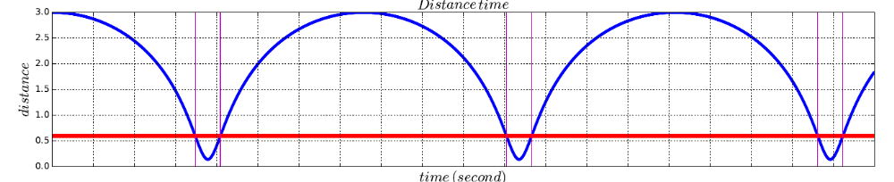
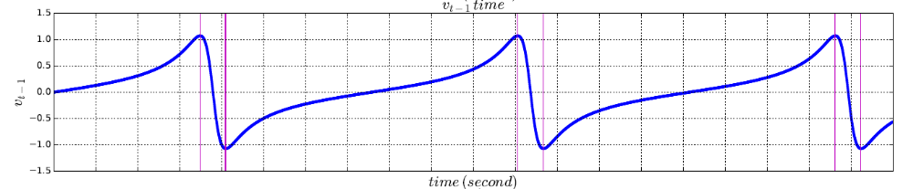
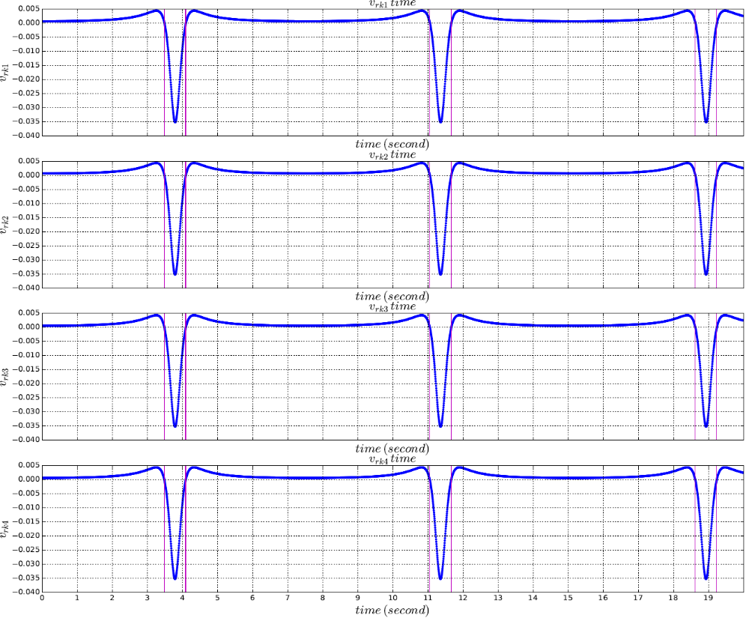
The red horizontal line shows the sum of radii of two particles = 0.3 + 0.3 = 0.6
The vertical purple line shows time t when two particles collide (distance between two particles = sum of two radii = 0.6)
We see that, when two particles collide, attractive and repulsive forces cancel each other. This makes ${\vec{v}}_{k_{1}}$= 0. From formula (6), we have ${\vec{x}}_{k_{1}}$= 0.
${\vec{v}}_{k_{2}}$ is then computed as formula (7) when two particles at the positions ${\vec{x}}_{t}+\frac{1}{2}{\vec{x}}_{k_{1}}$ . Since ${\vec{x}}_{k_{1}}$= 0 and ${\vec{x}}_{t}$ at the position where two particles collide, we still have ${\vec{v}}_{k_{2}}$= 0. Similarly, we can compute for other velocity and position coefficients.
However, we still see that, when two particles collide, $\vec{v}\left(t-1\right)$ = 1.0. Thus, the final velocity $\vec{v}\left(t\right)$ is computed from formula (1) is different from 0. It means particle still moves forwards with his previous velocity even when the attractive and repulsive forces cancel each other.
To make two particles stop with velocity = 0 when they collide, we need
$\vec{v}\left(t+Δt\right)=0$, from formula (1), we have
→ $\vec{v}\left(t\right)=- \frac{1}{6}\left({\vec{v}}_{k_{1}}+ 2{\vec{v}}_{k_{2}}+ 2{\vec{v}}_{k_{3}}+ {\vec{v}}_{k_{4}}\right)$
This means that velocity coefficients must have the opposite direction with current velocity $\vec{v}\left(t\right)$and their magnitude must be equal to |$\vec{v}\left(t\right)$|. This only occurs when the repulsive force whose magnitude must be high so that it can be negative and different from 0 after subtracted attractive force when computing two particles at overlapped positions at $t+\frac{Δt}{2}$ and $t+Δt$.
Thus, we need to set $A_{rep}$> $A_{att}$ . This work is also suggested by Helbing & Molnar.
${\vec{v}}_{k_{1}}$ =$Δt$ $f(t,{\vec{x}}_{t},{\vec{v}}_{t})$ (5)
${\vec{x}}_{k_{1}}$ = $Δt{\vec{v}}_{t}$ (6)

${\vec{v}}_{k_{2}}$ =$Δt$ $f(t+\frac{Δt}{2}, {\vec{x}}_{t}+\frac{1}{2}{\vec{x}}_{k_{1}},{\vec{v}}_{t}+ \frac{1}{2}{\vec{v}}_{k_{1}})$ (7)
${\vec{x}}_{k_{2}}$ = $Δt$ $({\vec{v}}_{t}+ \frac{1}{2}{\vec{v}}_{k_{1}})$ (8)

${\vec{v}}_{k_{3}}$ =$Δt$ $f(t+\frac{Δt}{2}, {\vec{x}}_{t}+\frac{1}{2}{\vec{x}}_{k_{2}},{\vec{v}}_{t}+ \frac{1}{2}{\vec{v}}_{k_{2}})$ (9)
${\vec{x}}_{k_{3}}$ = $Δt$ $({\vec{v}}_{t}+ \frac{1}{2}{\vec{v}}_{k_{2}})$ (10)

${\vec{v}}_{k_{4}}$ =$Δt$ $f(t+Δt, {\vec{x}}_{t}+{\vec{x}}_{k_{3}},{\vec{v}}_{t}+ {\vec{v}}_{k_{3}})$ (11)
${\vec{x}}_{k_{4}}$ = $Δt$ $({\vec{v}}_{t}+ {\vec{v}}_{k_{3}})$ (12)
After setting $A_{rep}$> $A_{att}$ and $B_{rep}$ < $B_{att}$, two particles will be stop when they collide. This is presented as below figure.
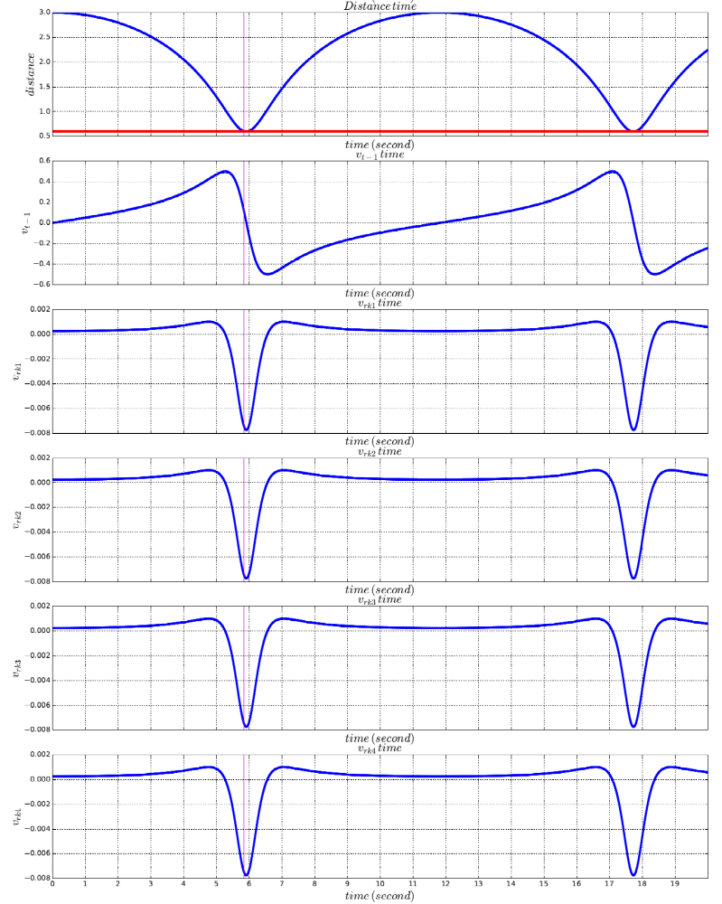
After they collide, since $A_{rep}$> $A_{att}$ and $B_{rep}$ < $B_{att}$, velocity coefficients are computed as formulas (5-12) and become negative. This makes particles move away.

